Task on Auto Scaling Groups

1. Create one VPC in N. Virginia region.
1. Objective
To create a Virtual Private Cloud (VPC) in the N. Virginia (us-east-1) AWS Region to provide an isolated virtual network for deploying AWS resources.
2. Steps / Implementation
- Log in to the AWS Management Console.
- Select the region US East (N. Virginia) – us-east-1 from the region selector.
- Search for VPC in the AWS Console and open the VPC Dashboard.
- Click Create VPC.
- Under Resources to create, select VPC only.
- Enter the following details:
  - Name tag: My-VPC
  - IPv4 CIDR block: 10.0.0.0/16
  - IPv6 CIDR block: No IPv6 CIDR block
  - Tenancy: Default
- Click Create VPC.
- After creation, verify that the VPC appears with:
  - Name: My-VPC
  - IPv4 CIDR: 10.0.0.0/16
  - State: Available
  - Region: N. Virginia (us-east-1)
3. Evidence / Screenshots
Take one screenshot showing the created VPC in the Your VPCs page.
The screenshot should clearly show:
- VPC name
- VPC ID
- IPv4 CIDR 10.0.0.0/16
- State Available
- Region should be N. Virginia / us-east-1
Suggested evidence caption:

Figure 1: VPC successfully created in the N. Virginia (us-east-1) region.
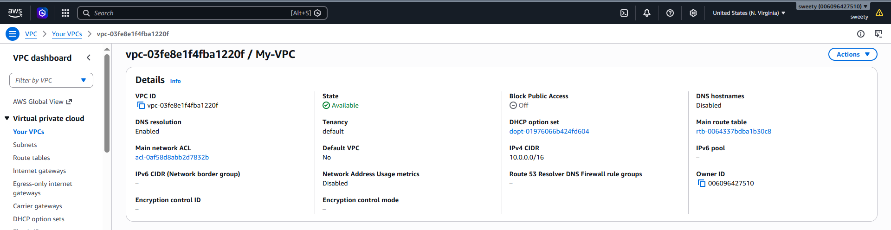
4. Conclusion
The VPC was successfully created in the N. Virginia (us-east-1) region with the IPv4 CIDR block 10.0.0.0/16. The VPC is available and ready for further network configuration.

Task 2: Create Two Subnets – One Public and One Private
1. Objective
To create two subnets within the previously created VPC, with one designated as a public subnet and the other as a private subnet, for organizing AWS resources based on their network accessibility.
2. Steps / Implementation
Assuming the VPC created in Task 1 has CIDR block 10.0.0.0/16:
A. Create the Public Subnet
- Open AWS Console → VPC.
- Go to Subnets from the left navigation menu.
- Click Create subnet.
- Select the VPC created in Task 1 (My-VPC).
- Enter:
  - Subnet name: Public-Subnet
  - Availability Zone: Select any AZ, for example us-east-1a
  - IPv4 subnet CIDR block: 10.0.1.0/24
- Click Create subnet.
B. Create the Private Subnet
- Click Create subnet again.
- Select the same VPC (My-VPC).
- Enter:
  - Subnet name: Private-Subnet
  - Availability Zone: Select another AZ, for example us-east-1b
  - IPv4 subnet CIDR block: 10.0.2.0/24
- Click Create subnet.
3. Important Note
Creating a subnet does not by itself make it public or private.
For this task, we are creating the two subnets and naming them accordingly. A subnet becomes publicly accessible when its route table has a route to an Internet Gateway. A private subnet normally does not have a direct route to an Internet Gateway.
If the assignment only asks to create two subnets, don't add an Internet Gateway or NAT Gateway unless a later task specifically asks for it.
4. Evidence / Screenshots
Take a screenshot of the Subnets page showing both subnets.
The screenshot should show:
Subnet | CIDR Block | Availability Zone
Public-Subnet | 10.0.1.0/24 | us-east-1a
Private-Subnet | 10.0.2.0/24 | us-east-1b
Figure 2: Two subnets, Public-Subnet and Private-Subnet, successfully created within the VPC.
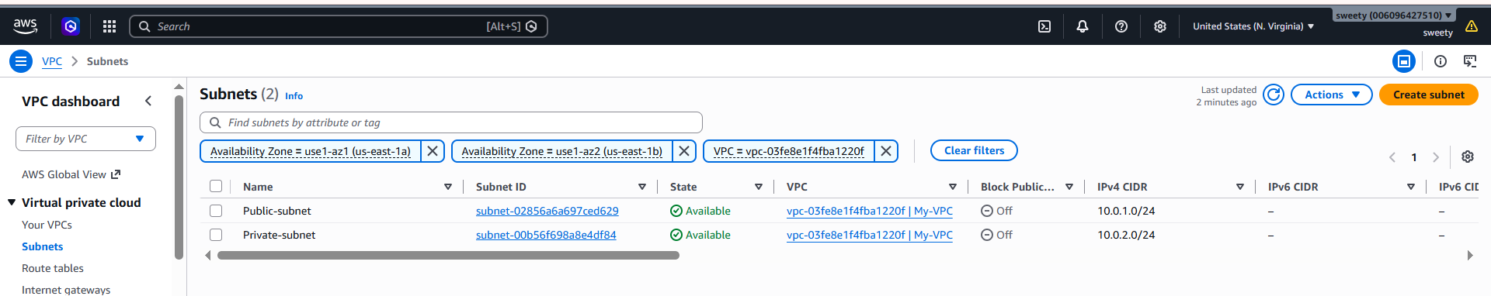
5. Conclusion
Two subnets were successfully created within the VPC: Public-Subnet (10.0.1.0/24) and Private-Subnet (10.0.2.0/24). These subnets can be used to separate resources based on their network accessibility.

Task 3: Attach an Internet Gateway (IGW) to the VPC
1. Objective
To create an Internet Gateway (IGW) and attach it to the previously created VPC so that resources in a public subnet can communicate with the internet when the appropriate route is configured.
2. Steps / Implementation
- Open AWS Console → VPC.
- From the left navigation menu, select Internet Gateways.
- Click Create internet gateway.
- Enter:
  - Name tag: My-IGW
- Click Create internet gateway.
- Select the newly created My-IGW.
- Click Actions → Attach to a VPC.
- Select the VPC created in Task 1:
  - VPC: My-VPC
- Click Attach internet gateway.
- Verify that the Internet Gateway status shows Attached and the correct VPC ID is displayed.
3. Evidence / Screenshot
screenshot of the Internet Gateways page showing:
- My-IGW
- State: Attached
- Your VPC ID
Figure 3: Internet Gateway successfully created and attached to the VPC.
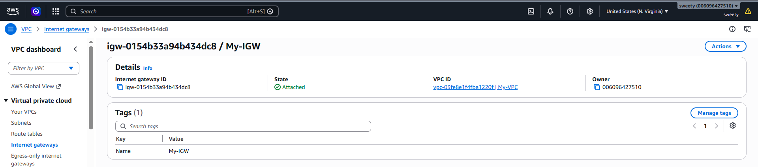
4. Conclusion
The Internet Gateway was successfully created and attached to the VPC. It provides a pathway for internet connectivity to resources in the VPC when a suitable route is configured in the public subnet's route table.

Task 4: Create One Public Route Table and One Private Route Table
1. Objective
To create two route tables within the VPC—one for the public subnet and one for the private subnet—to control the routing of network traffic.
2. Steps / Implementation
A. Create the Public Route Table
- Open AWS Console → VPC.
- From the left navigation menu, select Route Tables.
- Click Create route table.
- Enter:
  - Name: Public-RT
  - VPC: Select the VPC created in Task 1 (My-VPC)
- Click Create route table.
B. Create the Private Route Table
- Click Create route table again.
- Enter:
  - Name: Private-RT
  - VPC: Select the same VPC (My-VPC)
- Click Create route table.
3. Verify the Route Tables
After creation, go to Route Tables and verify that both route tables are present:
Route Table | VPC | Purpose
Public-RT | My-VPC | Public subnet routing
Private-RT | My-VPC | Private subnet routing
Note: At this stage, you only need to create the route tables. The public route to the Internet Gateway and subnet associations can be configured in the relevant later tasks if required.
4. Evidence / Screenshot
screenshot of the Route Tables page showing both:
- Public-RT
- Private-RT
- Same VPC ID
- Both route tables in the active state
Figure 4: Public and private route tables successfully created in the VPC.
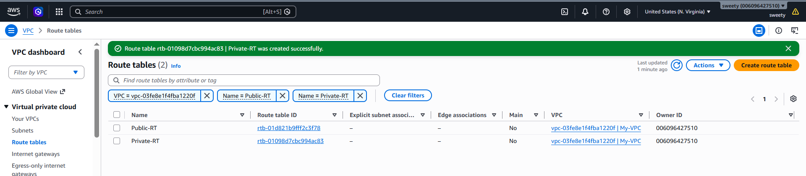
5. Conclusion
Two route tables were successfully created within the VPC: Public-RT for the public subnet and Private-RT for the private subnet. These route tables will be used to control traffic routing for their respective subnets.

Task 5: Deploy a NAT Gateway in the Public Subnet
1. Objective
To create a NAT Gateway in the public subnet so that resources in the private subnet can access the internet for outbound communication without being directly accessible from the internet.

2. Steps / Implementation
A. Allocate an Elastic IP
- Open AWS Console → VPC.
- Select Elastic IPs from the left navigation menu.
- Click Allocate Elastic IP address.
- Keep the default settings.
- Click Allocate.
- Note the allocated Elastic IP address.
B. Create the NAT Gateway
- From the VPC dashboard, select NAT Gateways.
- Click Create NAT gateway.
- Enter:
  - Name: My-NAT-Gateway
  - Subnet: Select Public-Subnet
  - Connectivity type: Public
  - Elastic IP allocation ID: Select the Elastic IP created above.
- Click Create NAT gateway.
- Wait until the NAT Gateway status changes from Pending to Available.
C. Route Private Subnet Traffic Through NAT Gateway
A NAT Gateway is not directly "attached" to a subnet. Instead, the private subnet's route table is configured to use the NAT Gateway.
- Go to VPC → Route Tables.
- Select Private-RT.
- Open the Routes tab.
- Click Edit routes → Add route.
- Enter:
  - Destination: 0.0.0.0/0
  - Target: Select NAT Gateway → My-NAT-Gateway
- Click Save changes.
This allows instances in the private subnet to access the internet outbound through the NAT Gateway, while they remain without a direct route from the internet.
3. Evidence / Screenshots
Take screenshots showing:
Screenshot 1 – NAT Gateway
- NAT Gateway name: My-NAT-Gateway
- Subnet: Public-Subnet
- Connectivity type: Public
- Elastic IP
- State: Available
Screenshot 2 – Private Route Table
- Private-RT selected
- Route: 0.0.0.0/0
- Target: My-NAT-Gateway
Figure 5(a): NAT Gateway successfully deployed in the public subnet.
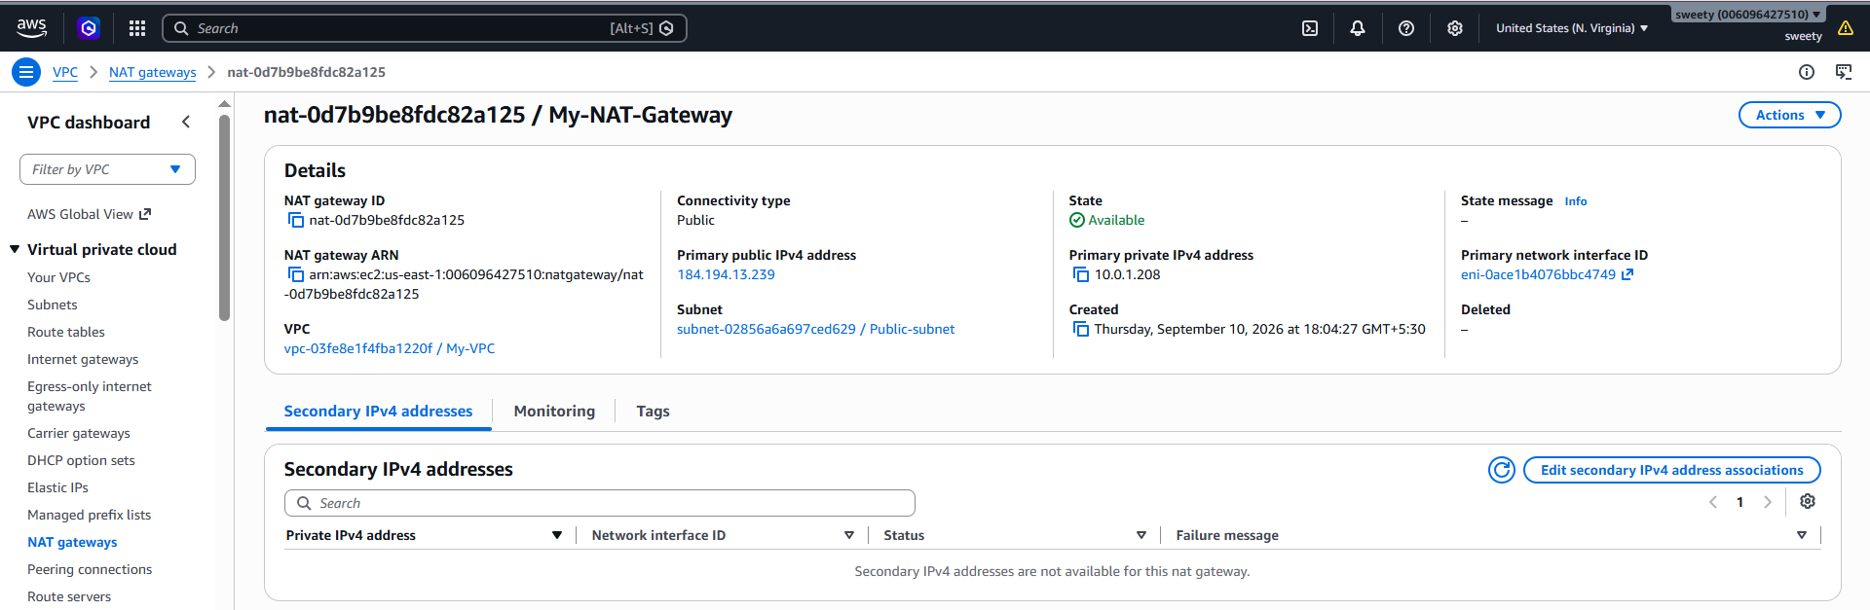
Figure 5(b): Private route table configured to route internet-bound traffic through the NAT Gateway.
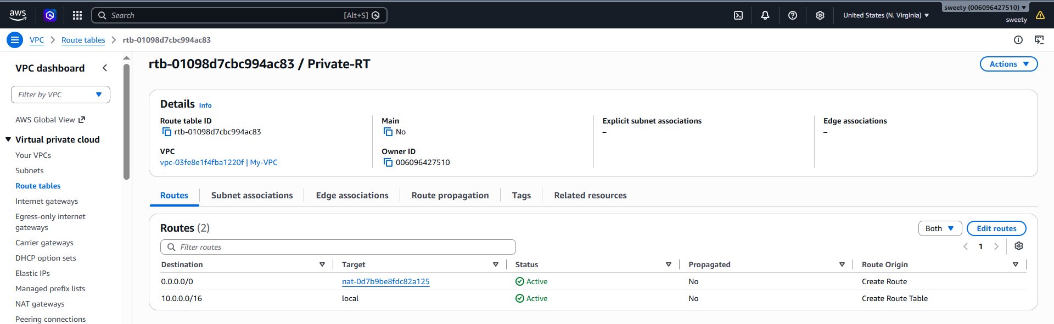
4. Conclusion
The NAT Gateway was successfully deployed in the Public-Subnet with an Elastic IP address. The Private-RT was configured with a default route through the NAT Gateway, allowing resources in the private subnet to access the internet for outbound communication while remaining private.
Important: NAT Gateway incurs AWS charges while it exists, so delete it after completing the lab if you don't need it anymore.

Task 6: Create Two EC2 Instances – One Public and One Private
1. Objective
To launch two EC2 instances within the VPC, placing one instance in the public subnet and the other in the private subnet, to demonstrate different levels of network accessibility.
2. Steps / Implementation
A. Create the Public EC2 Instance
- Open AWS Console → EC2.
- Click Launch instance.
- Enter:
  - Name: Public-Instance
  - AMI: Amazon Linux 2023
  - Instance type: t2.micro or the available free-tier eligible option.
- Select or create a Key pair for SSH access.
- Under Network settings, click Edit.
- Select:
  - VPC: My-VPC
  - Subnet: Public-Subnet
  - Auto-assign Public IP: Enable
- Configure the security group to allow SSH (port 22) from your own IP address.
- Click Launch instance.
B. Create the Private EC2 Instance
- Click Launch instance again.
- Enter:
  - Name: Private-Instance
  - AMI: Amazon Linux 2023
  - Instance type: t2.micro or the available free-tier eligible option.
- Select the same key pair if appropriate.
- Under Network settings → Edit, select:
  - VPC: My-VPC
  - Subnet: Private-Subnet
  - Auto-assign Public IP: Disable
- Configure the security group as required.
- Click Launch instance.
3. Verify the Instances
Go to EC2 → Instances and verify:

Instance | Subnet | Public IP
Public-Instance | Public-Subnet | Assigned
Private-Instance | Private-Subnet | None
The public instance should have a public IP because it is intended to be accessible from the internet.
The private instance should not have a public IP. It can use the NAT Gateway for outbound internet access, provided the private route table is configured correctly.
4. Evidence / Screenshots
Take one screenshot of the EC2 Instances page showing both instances.
Make sure the screenshot clearly shows:
- Instance names
- Instance state: Running
- Private IPv4 addresses
- Public IPv4 address for Public-Instance
- No public IPv4 address for Private-Instance
- Subnet information, if visible
Suggested evidence caption:
Figure 6: Two EC2 instances successfully launched, with one instance deployed in the public subnet and the other in the private subnet.
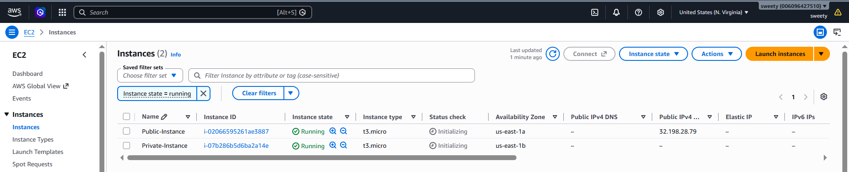
5. Conclusion
Two EC2 instances were successfully deployed within the VPC. The Public-Instance was launched in the public subnet with a public IP address, while the Private-Instance was launched in the private subnet without a public IP address. This demonstrates the separation between public and private resources in the VPC.

Task 7: Deploy Apache Server on Both EC2 Instances
1. Objective
To install and configure the Apache HTTP web server on both the public and private EC2 instances and create a sample index.html webpage to verify that Apache is running successfully.

2. Steps / Implementation
Assumption: Both EC2 instances are Amazon Linux 2023. The commands below are specifically for Amazon Linux 2023.
A. Public EC2 Instance
- Connect to the Public-Instance using SSH.
- Update the packages:
sudo dnf update -y
- Install Apache:
sudo dnf install httpd -y
- Start Apache:
sudo systemctl start httpd
- Enable Apache to start automatically after reboot:
sudo systemctl enable httpd
- Create the sample index.html file:
echo "<h1>Welcome to Public EC2 Instance</h1>" | sudo tee /var/www/html/index.html
- Verify Apache is running:
sudo systemctl status httpd
- Test locally:
curl http://localhost
You should see:
<h1>Welcome to Public EC2 Instance</h1>
B. Private EC2 Instance
Connect to the Private-Instance and run the same Apache installation steps:
sudo dnf update -y
sudo dnf install httpd -y
sudo systemctl start httpd
sudo systemctl enable httpd
Create its sample webpage:
echo "<h1>Welcome to Private EC2 Instance</h1>" | sudo tee /var/www/html/index.html
Verify Apache:
sudo systemctl status httpd
Test locally:
curl http://localhost
You should see:
<h1>Welcome to Private EC2 Instance</h1>
3. Security Group Configuration
Make sure the security groups allow HTTP traffic on port 80.
For the Public-Instance, allow:
- HTTP – TCP – Port 80
- Source: 0.0.0.0/0 if you need to access the webpage from your browser.
For the Private-Instance, HTTP access can be restricted to the VPC/private network rather than allowing the entire internet.
4. Evidence / Screenshots
Take screenshots from both instances.
Screenshot 1 – Public Instance
Show:
sudo systemctl status httpd
and/or:
curl http://localhost
The output should confirm Apache is running and display:
Welcome to Public EC2 Instance
Screenshot 2 – Private Instance
Show:
sudo systemctl status httpd
and/or:
curl http://localhost
The output should display:
Welcome to Private EC2 Instance
Screenshot 3 – Browser Test (Public Instance)
Open:
http://<Public-Instance-Public-IP>
The browser should display:
Welcome to Public EC2 Instance

Figure 7(a): Apache successfully installed and running on the public EC2 instance.
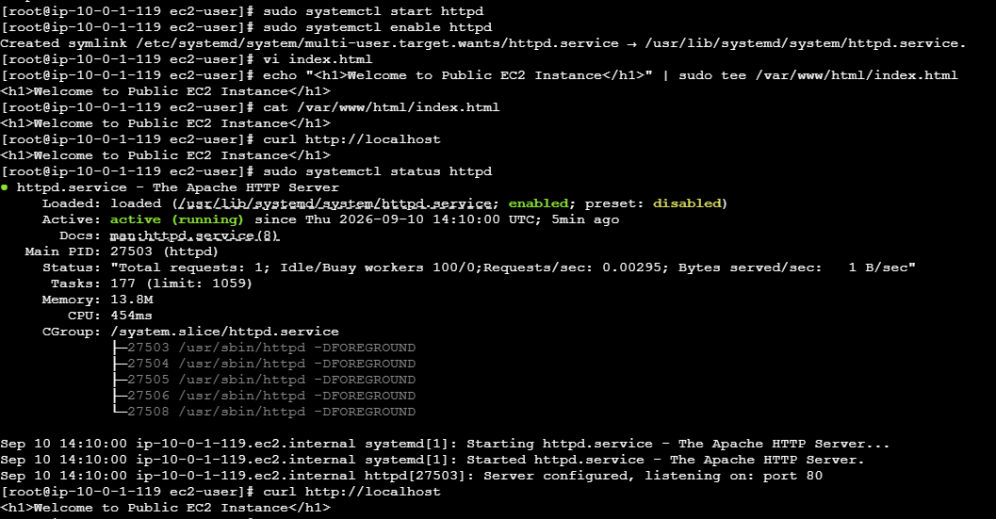
Figure 7(b): Apache successfully installed and running on the private EC2 instance.
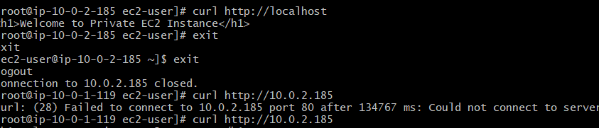

Figure 7(c): Sample webpage successfully accessed from the public EC2 instance.
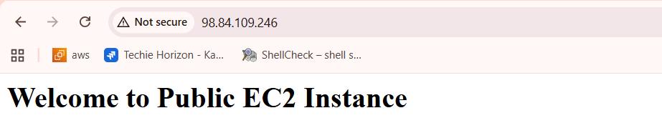
5. Conclusion
Apache HTTP Server was successfully installed and configured on both EC2 instances. A separate index.html file was created on each instance, and the webpages were successfully verified using curl. The public instance can be accessed through its public IP, while the private instance remains accessible only through the private network.
Send Task 8.

You've reached the limit for file attachments
Attachments are unavailable until usage resets at 10:27 PM. Upgrade for expanded access and advanced intelligence.

8. Create an Application Load Balancer and Attach It to Both EC2 Instances
Objective
To create an Application Load Balancer (ALB) and configure it to distribute HTTP traffic between the Public EC2 instance and Private EC2 instance.
Steps / Implementation
Step 1: Prepare the subnets
An Application Load Balancer requires subnets in at least two Availability Zones.
Our current setup has:
- Public subnet: 10.0.1.0/24 — us-east-1a
- Private subnet: 10.0.2.0/24 — us-east-1b
Because the ALB should be internet-facing, we need two public subnets in different Availability Zones.
So first, we will create another public subnet, for example:
- New Public Subnet: 10.0.3.0/24
- Availability Zone: us-east-1b
- Route table: Public-RT
Step 2: Create a Target Group
Create a target group with:
- Target type: Instances
- Protocol: HTTP
- Port: 80
- VPC: My-VPC
Register both:
- Public-Instance
- Private-Instance
The target group will perform health checks on port 80.
Step 3: Configure Security Groups
The ALB Security Group should allow:
HTTP (TCP 80)
Source: 0.0.0.0/0
The EC2 Security Groups should allow HTTP traffic from the ALB Security Group.
Step 4: Create the Application Load Balancer
Create:
- Load balancer type: Application Load Balancer
- Scheme: Internet-facing
- IP address type: IPv4
- VPC: My-VPC
- Availability Zones:
  - us-east-1a → Public subnet
  - us-east-1b → New Public subnet
Step 5: Configure Listener
Create an HTTP listener:
Protocol: HTTP
Port: 80
Default action: Forward to the target group
Step 6: Verify Target Health
Go to:
EC2 → Target Groups → Targets
Both EC2 instances should eventually show:
Healthy
Step 7: Test the ALB
Copy the ALB's DNS name and open it in your browser.
For example:
http://<ALB-DNS-name>
The request should be forwarded to one of the EC2 instances.
Because the two servers have different pages:
Public EC2:
Welcome to Public EC2 Instance
Private EC2:
Welcome to Private EC2 Instance
you can use the response to verify that the ALB is distributing traffic between them.
Evidence / Screenshots
- Second public subnet showing its CIDR and Availability Zone.
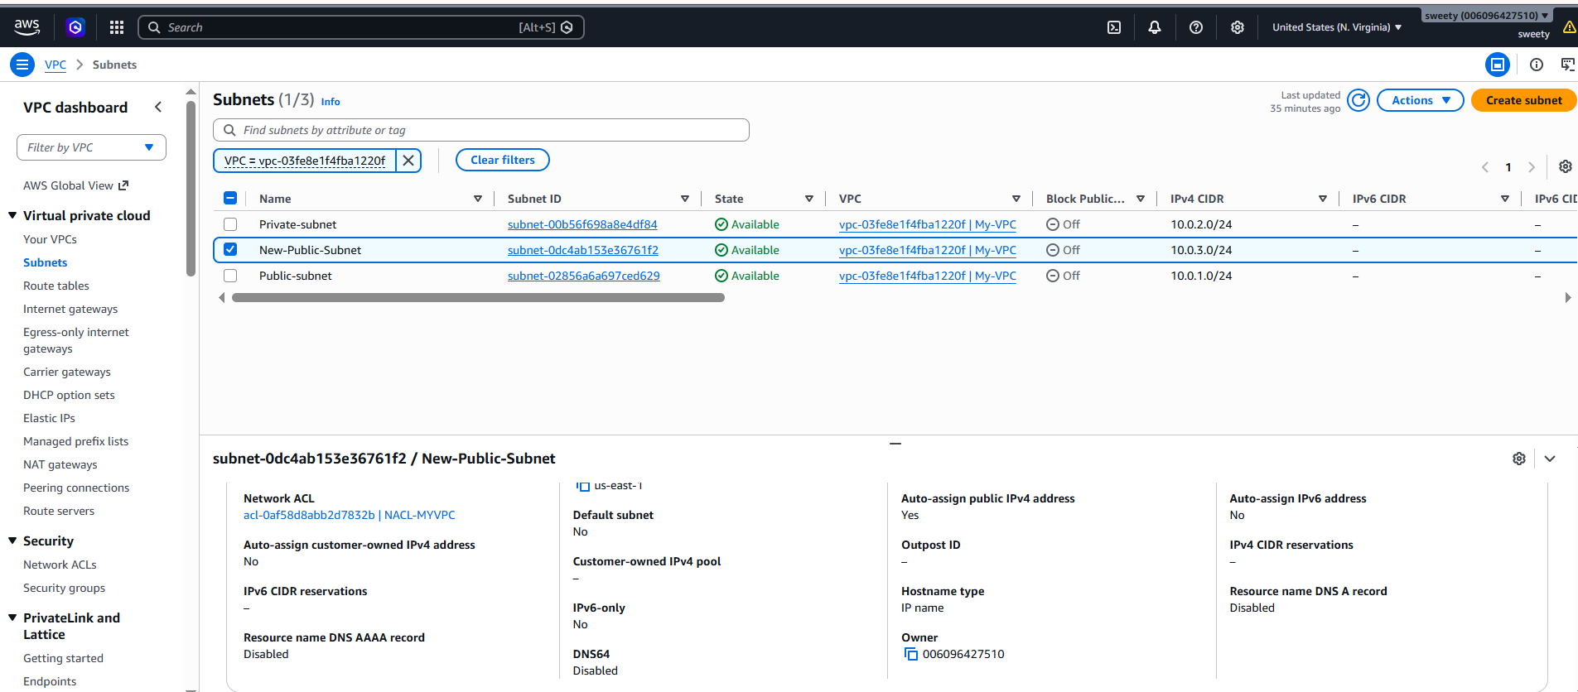
- Target Group → Targets showing both EC2 instances.
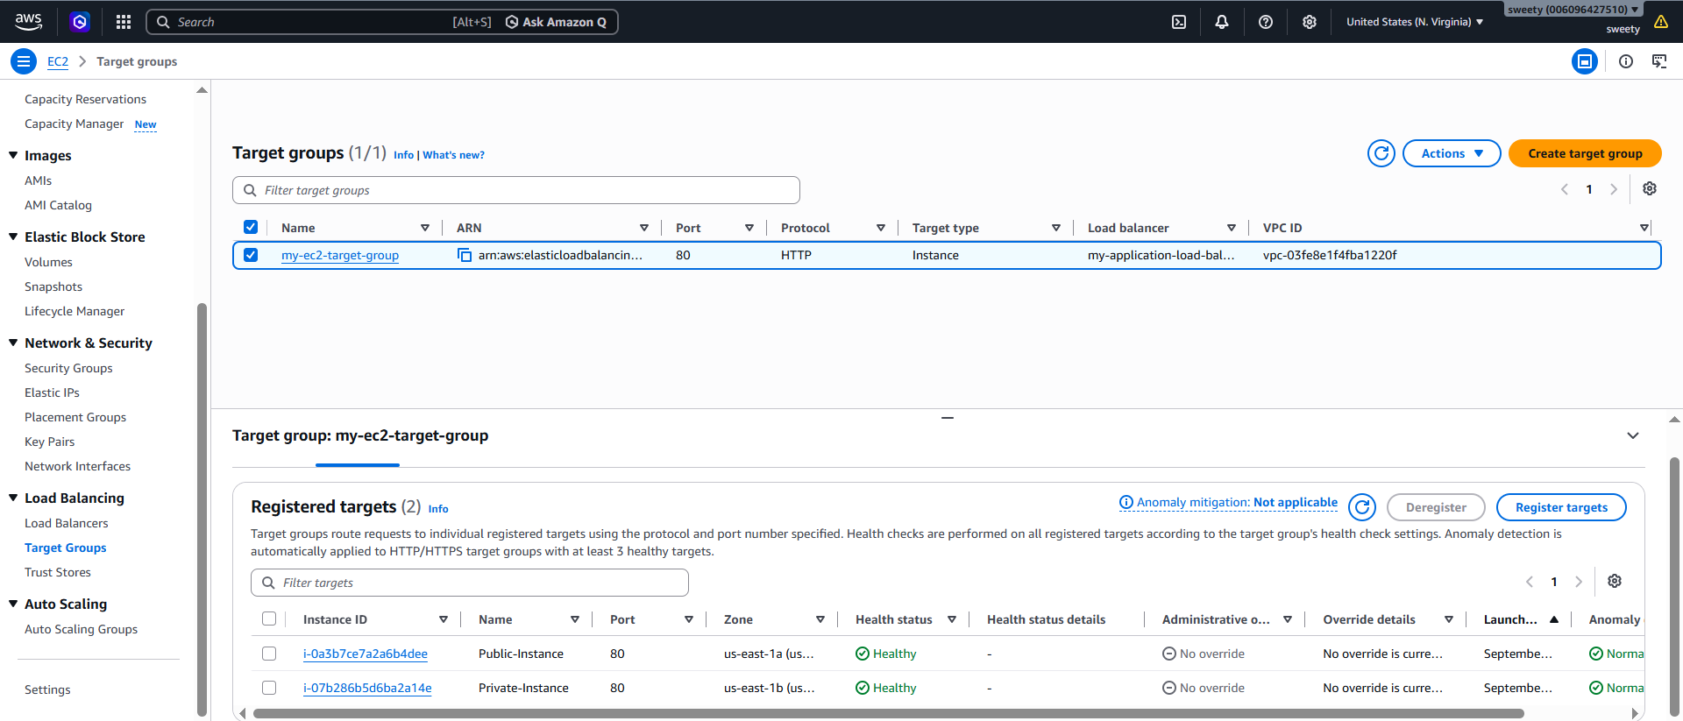
- Load Balancer details showing the ALB is active.
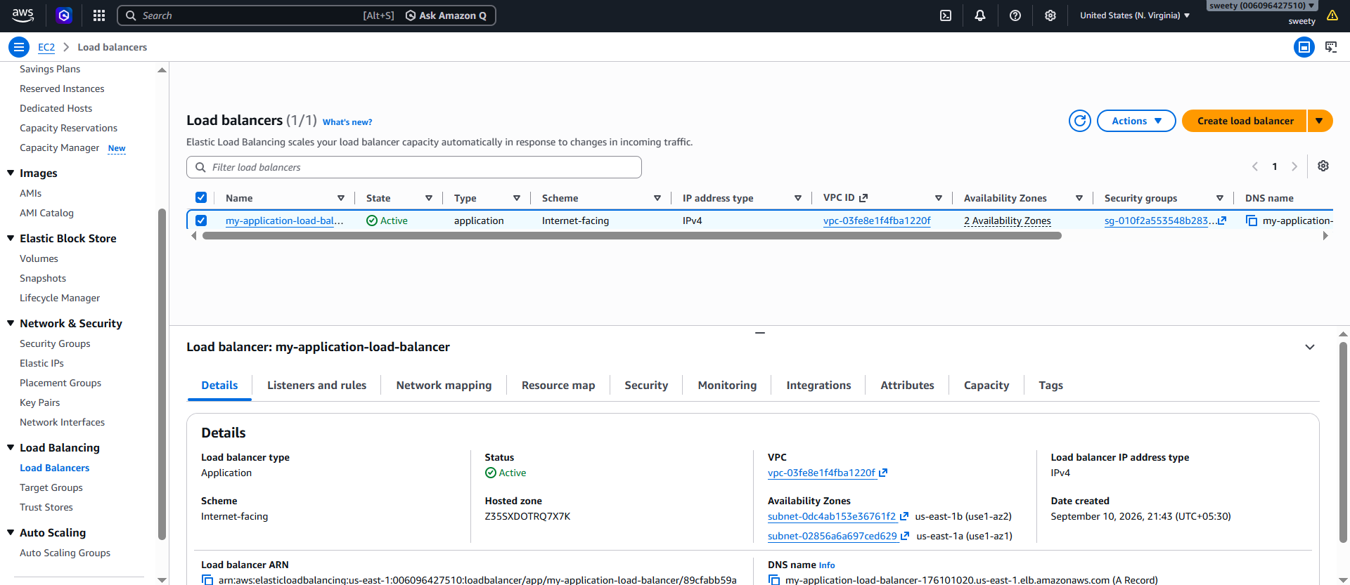
- Listener showing HTTP port 80 forwarding to the target group.
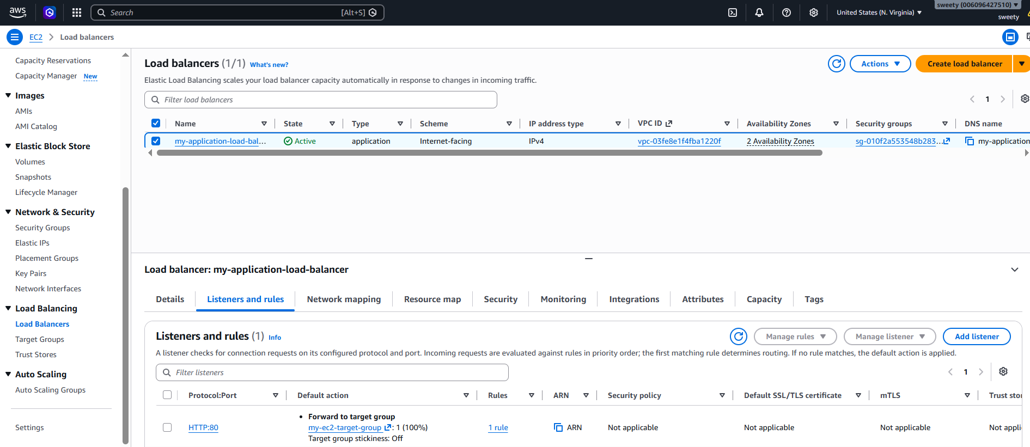
- ALB DNS name opened in the browser showing the EC2 web page.
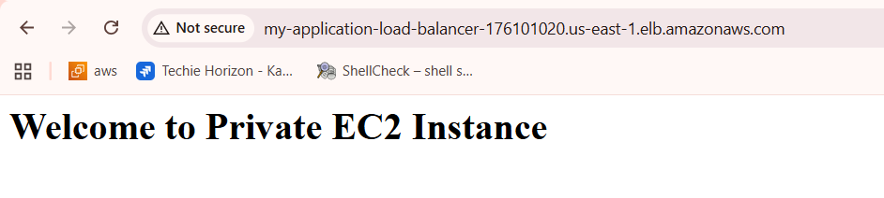
Conclusion
The Application Load Balancer was successfully created and configured to distribute HTTP traffic between the Public and Private EC2 instances. Both instances were registered as targets, and the ALB forwards incoming requests to the healthy EC2 instances.

Task 9 — Store ALB Logs in S3
Objective
To enable access logging for the Application Load Balancer and store the generated log files in an Amazon S3 bucket for monitoring and analysis.
Steps / Implementation
Step 1 — Create an S3 bucket
Go to:
AWS Console → S3 → Create bucket
Use a globally unique name, for example:
my-alb-logs-sweety-2026
Choose:
- AWS Region: US East (N. Virginia) us-east-1
- Object Ownership: ACLs disabled
- Block all public access: Keep enabled
- Bucket Versioning: Disabled
- Leave other settings as default.
Click Create bucket.
Step 2 — Configure S3 Bucket Policy
- Go to S3 → your ALB logs bucket.
- Open the Permissions tab.
- Scroll to Bucket policy.
- Click Edit.
- Paste this policy:
{
"Version": "2012-10-17",
"Statement": [
{
"Effect": "Allow",
"Principal": {
"Service": "logdelivery.elasticloadbalancing.amazonaws.com"
},
"Action": "s3:PutObject",
"Resource": "arn:aws:s3:::YOUR-BUCKET-NAME/AWSLogs/006096427510/*"
}
]
}
Important
Replace:
YOUR-BUCKET-NAME
Step 3 — Enable Access Logs on the ALB
- Go to AWS Console → EC2.
- In the left menu, select Load Balancers.
- Click your ALB:
my-application-load-balancer
- Select the Attributes tab.
- Find Monitoring / Access logs.
- Click Edit.
- Turn Access logs → On.
- For S3 URI, enter:
s3://YOUR-BUCKET-NAME
For example:
s3://my-alb-logs-sweety-2026
Do not add /AWSLogs/... yourself — AWS handles the log path.
- Click Save changes.
Step 4 — Generate some traffic
After saving, open your ALB DNS address in the browser a few times:
http://my-application-load-balancer-176101020.us-east-1.elb.amazonaws.com
Then wait a few minutes because ALB access logs aren't necessarily delivered immediately.
After that, go to:
S3 → your bucket → Objects
You should eventually see an AWSLogs/ folder containing the ALB log files.

Evidence screenshots for Task 9
Take these screenshots:
- ALB Attributes → Access logs: On with the S3 bucket configured.
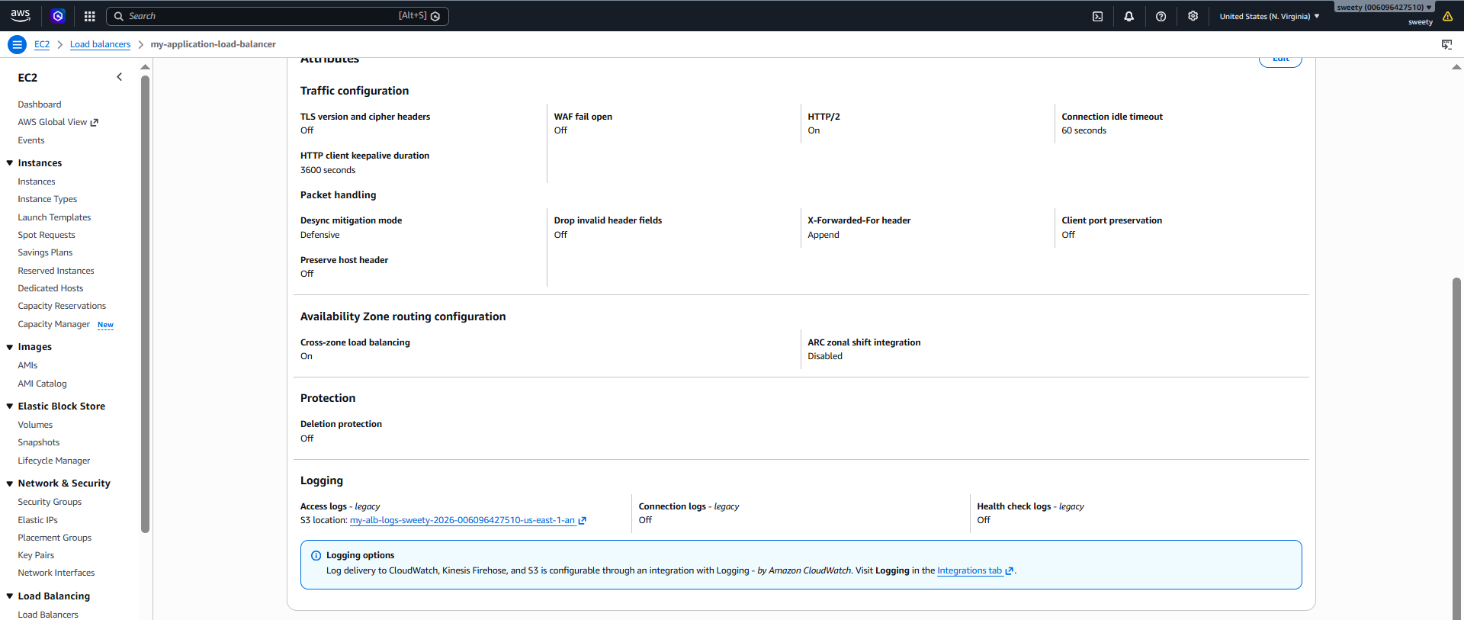
- S3 bucket → Objects showing the AWSLogs folder.
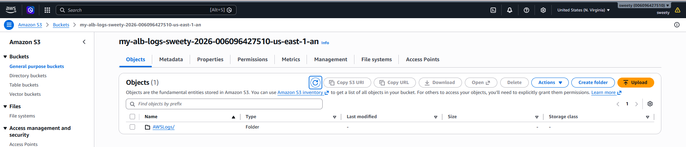
- If available, open the folder and show the generated log file.
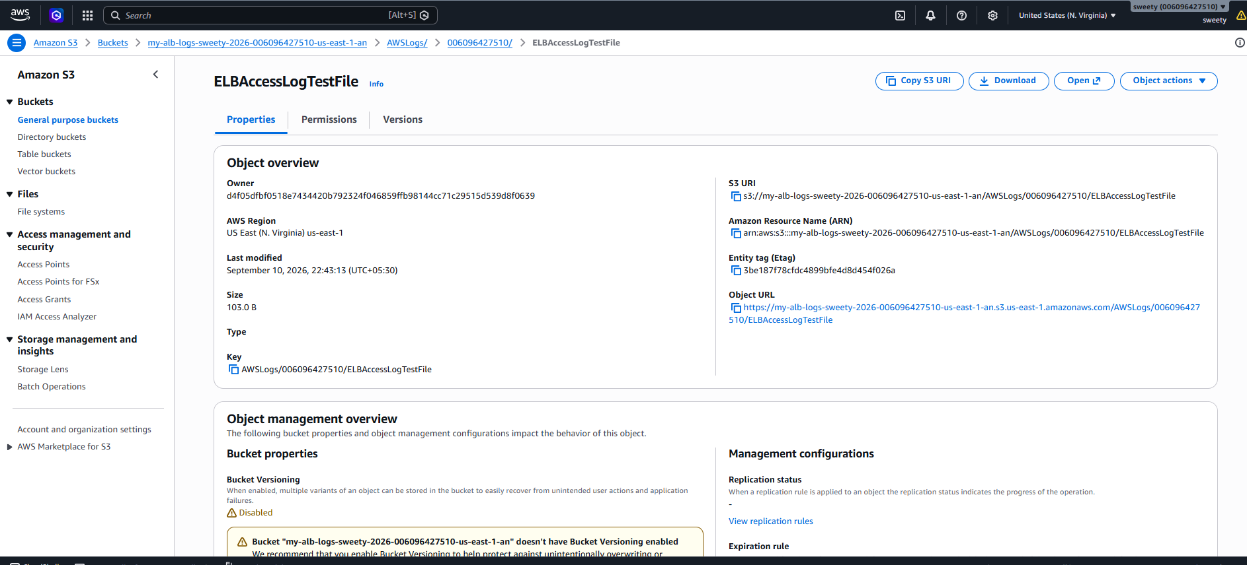

Conclusion
The Application Load Balancer access logs were successfully enabled and configured to store request logs in an Amazon S3 bucket. The ALB is now able to capture and store access log information in S3 for monitoring, troubleshooting, and analysis.

Task 10 — Store VPC Flow Logs in CloudWatch Log Group
Objective
To configure VPC Flow Logs to capture network traffic information from the VPC and store the logs in an Amazon CloudWatch Log Group for monitoring and analysis.
Steps / Implementation
We'll use your existing VPC:
VPC: My-VPC
VPC ID: vpc-03fe8e1f4fba1220f
Step 1 — Create a CloudWatch Log Group
- Go to AWS Console → CloudWatch.
- Select Log groups from the left menu.
- Click Create log group.
- Enter:
/vpc/flow-logs
- Leave the other settings as default.
- Click Create.
Step 2 — Create an IAM Role for VPC Flow Logs
Go to:
AWS Console → IAM → Roles → Create role
- Click Create role.
- Under Trusted entity type, select AWS service.
- For Service or use case, choose EC2.
- Click Next.
- In Permissions policies, search for:
CloudWatchLogsFullAccess
- Select CloudWatchLogsFullAccess.
- Click Next.
- Role name:
VPCFlowLogsRole
- Click Create role.
Step 3 — Create VPC Flow Log
Now go to:
AWS Console → VPC → Your VPCs
- Select My-VPC (vpc-03fe8e1f4fba1220f).
- Click Actions.
- Select Create flow log.
Enter:
- Name: My-VPC-Flow-Logs
- Filter: All
- Maximum aggregation interval: 1 minute
- Destination: Send to CloudWatch Logs
- Destination log group: /vpc/flow-logs
- IAM role: VPCFlowLogsRole
If AWS asks for the Log format, leave it as AWS default format.
Then click Create flow log.
Step 4 — Verify Flow Logs in CloudWatch
- Go to AWS Console → CloudWatch.
- Select Logs → Log Management → Log groups.
- Open:
/vpc/flow-logs
- You should see a log stream.
- Open the log stream and check for flow-log records containing information such as:
  - Source IP
  - Destination IP
  - Source port
  - Destination port
  - Protocol
  - Action (ACCEPT / REJECT)
If the log stream is empty initially, generate some traffic in your VPC—for example, access your ALB or connect to your EC2 instances—and wait a few minutes.
📸 Evidence / Screenshots
- VPC → Flow Logs showing My-VPC-Flow-Logs as Active.
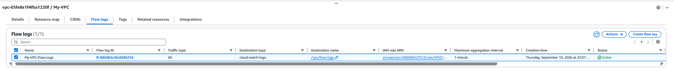

- CloudWatch → /vpc/flow-logs showing the log stream.
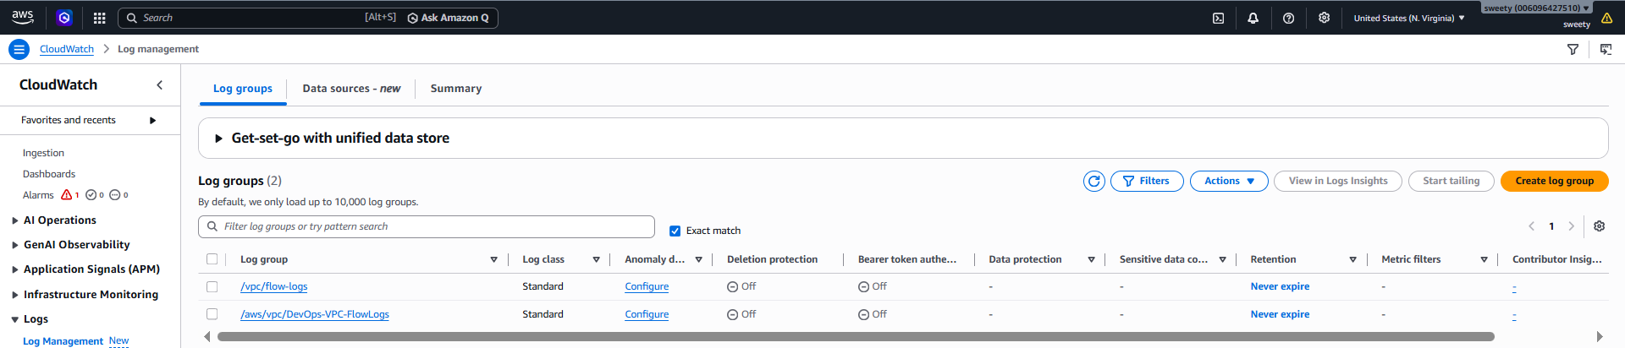
- A log stream containing flow-log records.
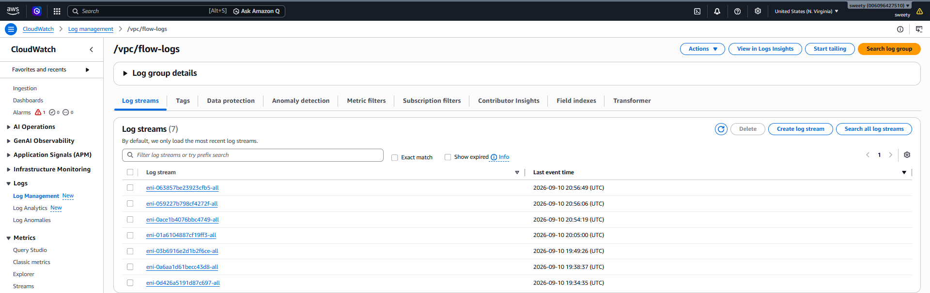
Conclusion
VPC Flow Logs were successfully configured for My-VPC and are being delivered to the /vpc/flow-logs CloudWatch Log Group. The logs provide network traffic information that can be used for monitoring, troubleshooting, and security analysis.

11. Create monitoring dashboards to monitor CPU utilization and to monitor the Apache service.
Objective
To create a CloudWatch monitoring dashboard to monitor EC2 CPU utilization and the Apache web server service, enabling easy monitoring of system performance and service availability.

Step 1 — Create a CloudWatch Dashboard
Go to:
AWS Console → CloudWatch → Dashboards
- Click Create dashboard.
- Enter dashboard name:
EC2-Apache-Monitoring
- Click Create.
Step 2 — Add CPU Utilization
Now you should be inside your EC2-Apache-Monitoring dashboard.
- Click Add widget.
- Select Line.
- Click Next.
- Select Metrics.
- Go to:
EC2 → Per-Instance Metrics
- Find your Public-Instance:
i-0a3b7ce7a2a6b4dee
- Select:
CPUUtilization
- Click Create widget / Create.
- Give the widget a title such as:
Public EC2 CPU Utilization
- Click Save dashboard.
Evidence: Take a screenshot showing the dashboard with the CPU Utilization graph.
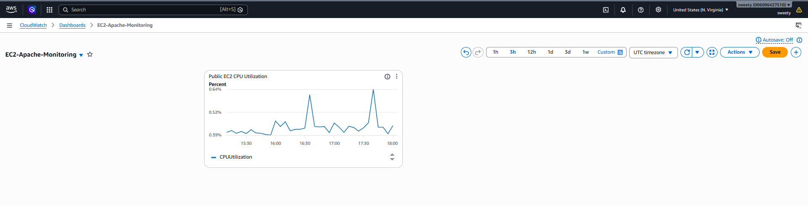
Next step — Add ApacheStatus to your dashboard
You already have the EC2-Apache-Monitoring dashboard.
On this CloudWatch metrics page:
- Select the ApacheStatus metric row.
- Click Actions.
- Choose Add to dashboard.
- Select EC2-Apache-Monitoring.
- Choose Add to dashboard.
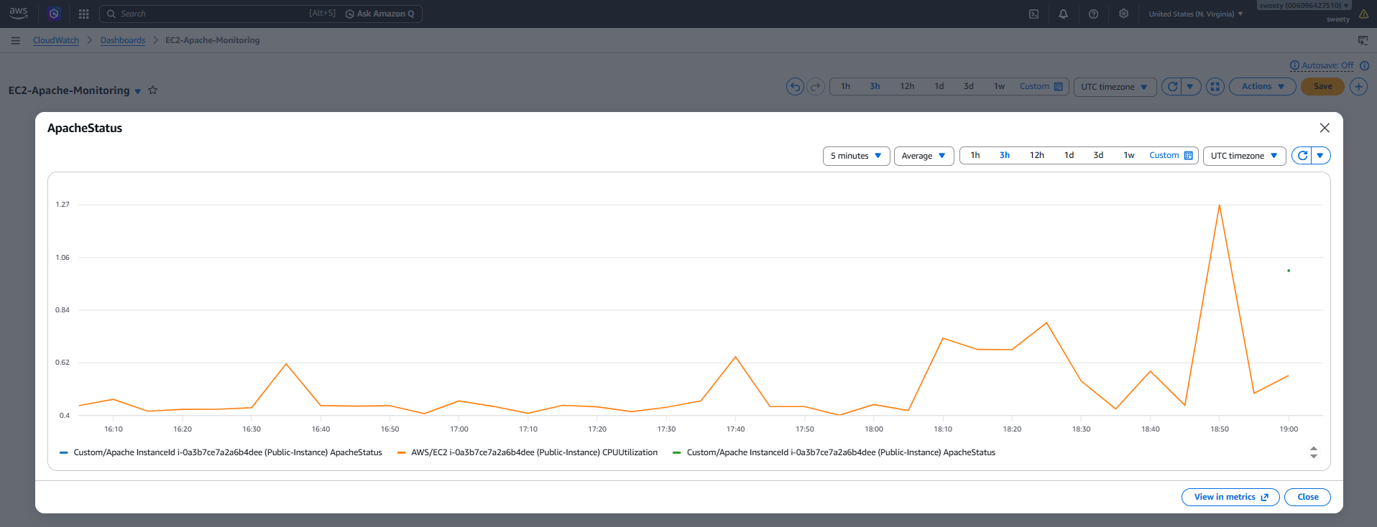
CloudWatch → Dashboards → EC2-Apache-Monitoring
You should have two monitoring widgets:
- 📊 Public EC2 CPU Utilization
- 📊 ApacheStatus
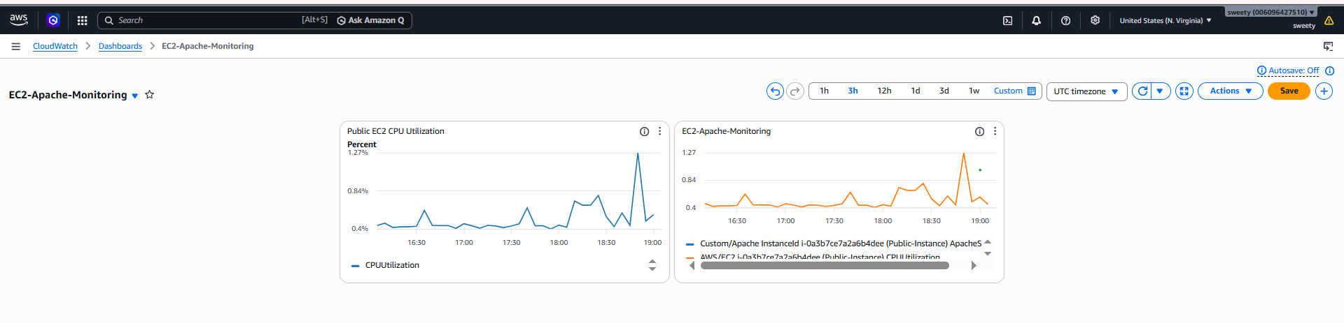

Task 12: Configure Auto Scaling Based on CPU Utilization
Objective
To configure Auto Scaling so that when the CPU utilization of an EC2 instance exceeds 70%, a CloudWatch alarm is triggered and the Auto Scaling Group automatically launches a new EC2 instance.
Implementation / Steps
Step 1: Create an Auto Scaling Group
- Open the AWS Management Console.
- Navigate to EC2 → Auto Scaling Groups.
- Click Create Auto Scaling group.
- Enter the Auto Scaling Group name:
My-AutoScaling-Group
- Select the launch template:
Public-Instance-Template
- Select the VPC:
My-VPC
- Select the public subnets:
  - Public-subnet
  - New-Public-Subnet
- Set the capacity:
  - Minimum: 1
  - Desired: 1
  - Maximum: 2
- Configure the required settings and create the Auto Scaling Group.
- Verify that one EC2 instance is running under the Auto Scaling Group.
Step 2: Create a CPU-Based Scaling Policy
- Open EC2 → Auto Scaling Groups.
- Select My-AutoScaling-Group.
- Open the Automatic scaling tab.
- Add a scaling policy.
- Select Simple scaling.
- Enter the policy name:
CPU-Above-70-Scale-Out
- Configure the policy to:
  - Add: 1 capacity unit
  - Wait: 300 seconds
- Save the scaling policy.
This policy increases the Auto Scaling Group capacity by one instance when the associated CloudWatch alarm is triggered.
Step 3: Create the CloudWatch Alarm
- Open CloudWatch → Alarms.
- Create a new alarm for EC2 CPU utilization.
- Select:
  - Namespace: AWS/EC2
  - Metric: CPUUtilization
  - Instance: i-062f73909af62914d
  - Statistic: Average
  - Period: 1 minute
- Configure the condition:
  - CPUUtilization > 70
  - Datapoints: 1 out of 1
- Under Configure actions, select the Auto Scaling action associated with:
CPU-Above-70-Scale-Out
- Name the alarm:
CPU-Above-70-Scaling-Alarm
- Review the configuration and click Update alarm/Create alarm.
Step 4: Generate High CPU Utilization
- Connect to the EC2 instance managed by the Auto Scaling Group.
- Generate CPU load using Python:
python3 -c "while True: pass" &
python3 -c "while True: pass" &
- Open the EC2 Monitoring tab.
- Check CPU utilization.
- The CPU utilization increased to approximately 99.96%, which is greater than the configured 70% threshold.
Step 5: Verify the CloudWatch Alarm
- Open CloudWatch → Alarms.
- Select CPU-Above-70-Scaling-Alarm.
- Verify that the alarm state changes to:
In alarm
This confirms that the CPU utilization condition has been met.
Step 6: Verify Auto Scaling
- Open EC2 → Auto Scaling Groups.
- Select My-AutoScaling-Group.
- Check the Capacity overview.
- Verify that:
  - Minimum: 1
  - Desired: 2
  - Maximum: 2
- Open Instance management.
- Verify that 2 EC2 instances are now associated with the Auto Scaling Group.
The desired capacity changed from 1 to 2, confirming that the scaling policy launched an additional instance.
Evidence / Screenshots
Screenshot 1 – Auto Scaling Group
Capture the My-AutoScaling-Group capacity overview showing:
- Desired capacity: 1 initially
- Minimum: 1
- Maximum: 2
- Launch template: Public-Instance-Template
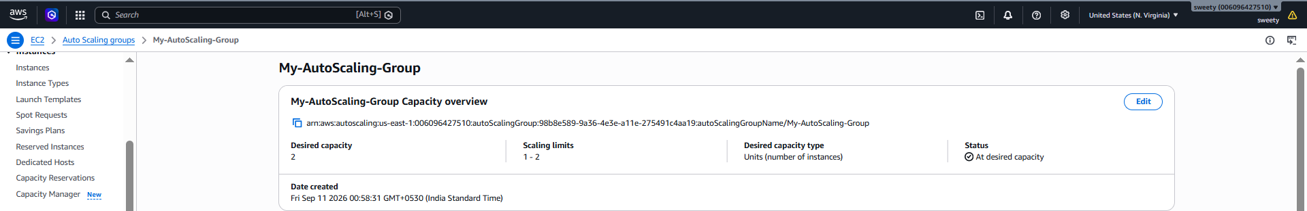
Screenshot 2 – Scaling Policy
Capture the Automatic scaling tab showing:
- Policy name: CPU-Above-70-Scale-Out
- Policy type: Simple scaling
- Action: Add 1 capacity unit
- Wait: 300 seconds
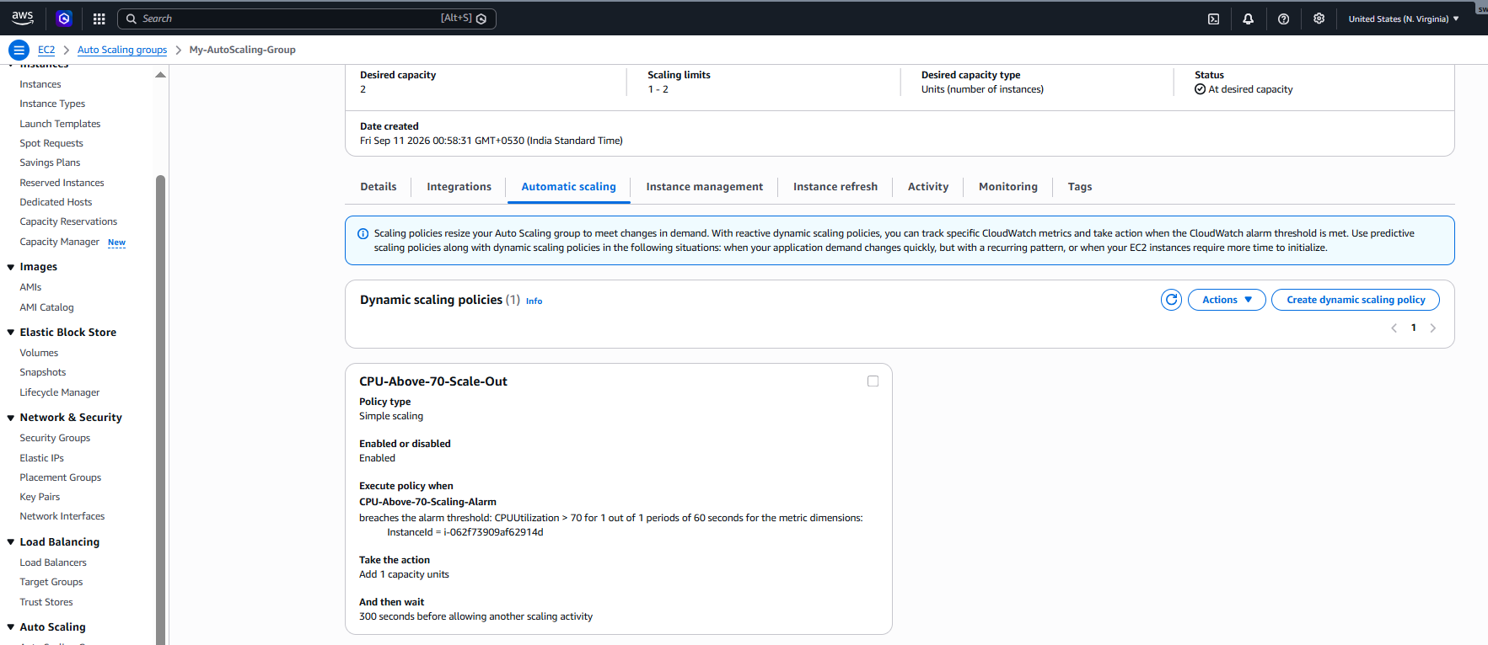
Screenshot 3 – CloudWatch Alarm Configuration
Capture the alarm configuration showing:
- Metric: CPUUtilization
- Instance ID: i-062f73909af62914d
- Statistic: Average
- Period: 1 minute
- Condition: CPUUtilization > 70
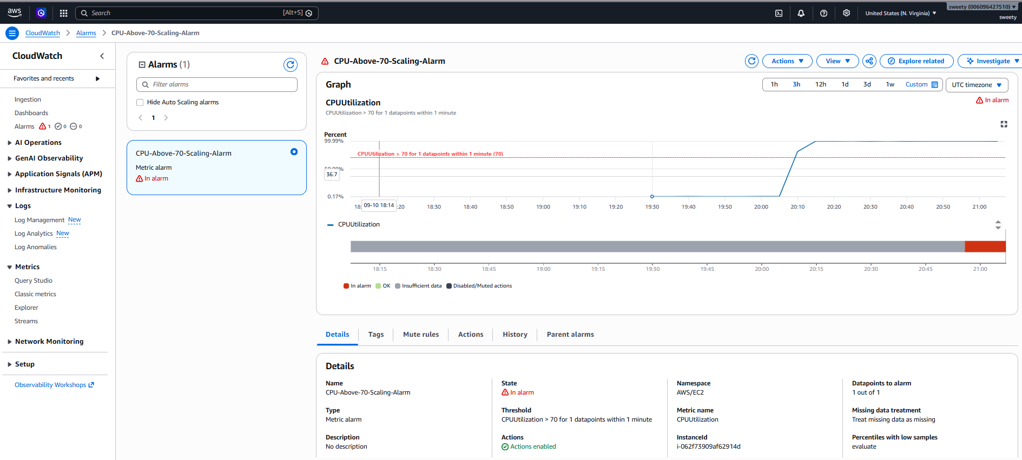

Screenshot 4– CloudWatch Alarm in Alarm State
Capture CPU-Above-70-Scaling-Alarm showing:
State: In alarm
This proves that the CloudWatch alarm was triggered.
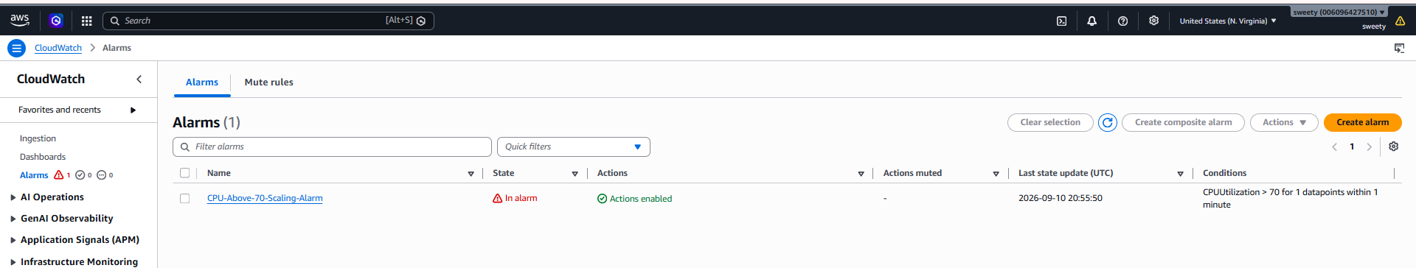
Screenshot 6 – Auto Scaling Launched New Instance
Capture My-AutoScaling-Group → Instance management showing 2 instances.
Also capture the Capacity overview showing:
Desired capacity: 2
This is the most important evidence because it proves that Auto Scaling launched an additional instance.
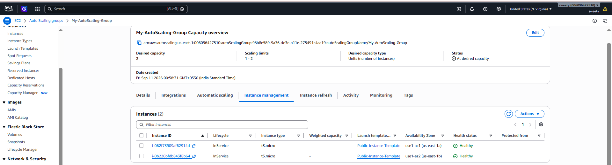

Conclusion
The Auto Scaling configuration was successfully implemented. When the EC2 instance CPU utilization increased above the configured 70% threshold, the CloudWatch alarm changed to In alarm. The associated Auto Scaling policy automatically increased the desired capacity from 1 to 2 and launched a new EC2 instance successfully. Therefore, CPU-based automatic scaling was successfully configured and verified.

